DATA ANALYSIS INTERNSHIP – DAY 11 REPORT
Organization: Top Tech Developers
Topic Covered: Home Task – Graph Plotting using Matplotlib
On Day 11 of the internship, a home assignment was completed using Matplotlib in Google Colab. Different graph plotting techniques were practiced using two random variables to understand data visualization concepts and graphical representation.

Introduction
Matplotlib is a Python library used for creating graphs and data visualizations. It helps represent numerical data in graphical format for analysis and better understanding. It is widely used in Data Analysis, Machine Learning, and Data Science projects.
Import Statement
import matplotlib.pyplot as plt
Explanation
- matplotlib → Main visualization library
- pyplot → Module used for graph plotting
- plt → Alias name used for easy access

Home Task
Creation of 2 Random Variables and Different Graphs
Different graph plotting techniques were implemented using Matplotlib based on random values.
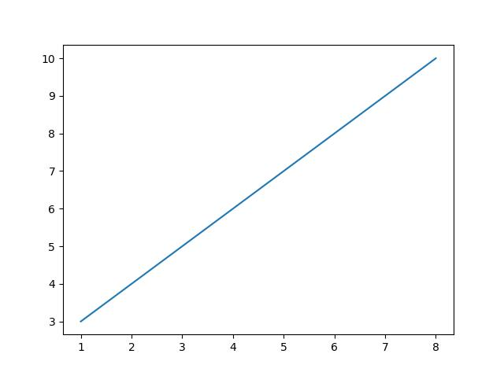
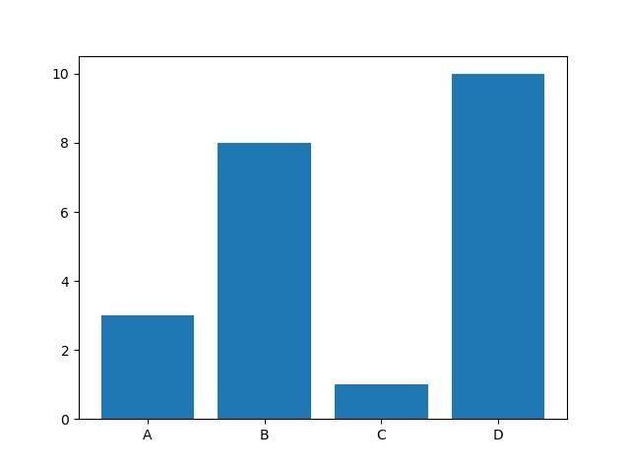
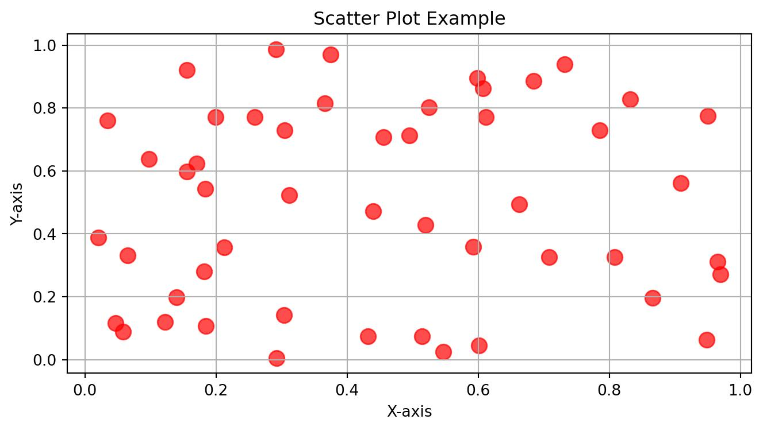
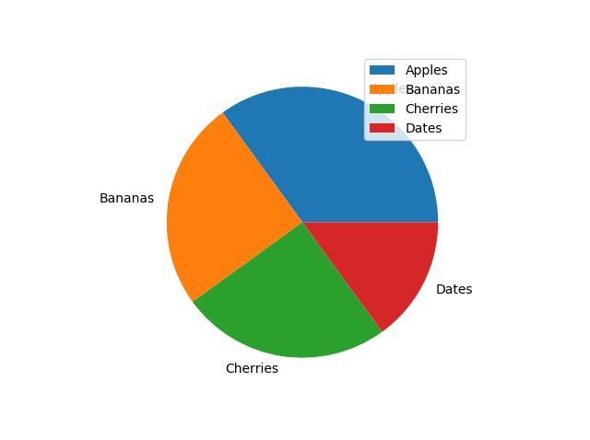

1. Line Graph
A line graph was created using numerical values for x and y variables.
Program
import matplotlib.pyplot as plt

x = [1,2,3,4,5]
y = [10,20,30,40,50]

plt.plot(x,y)
plt.xlabel("X Values")
plt.ylabel("Y Values")
plt.title("Line Graph")
plt.show()
Functions Used
- plt.plot() → Creates line graph
- plt.xlabel() → Adds x-axis label
- plt.ylabel() → Adds y-axis label
- plt.title() → Adds graph title
- plt.show() → Displays graph
Observation
- The line graph connects data points using a straight line.
- It is useful for identifying trends over values.

2. Bar Graph
A bar graph was created using category values.
Program
import matplotlib.pyplot as plt

x = ["A","B","C","D"]
y = [20,40,60,80]

plt.bar(x,y)
plt.xlabel("Categories")
plt.ylabel("Values")
plt.title("Bar Graph")
plt.show()
Functions Used
- plt.bar() → Creates bar graph
- plt.xlabel() → Adds x-axis label
- plt.ylabel() → Adds y-axis label
- plt.title() → Adds graph title
- plt.show() → Displays graph
Observation
- Bar graphs help compare values across categories.
- They are useful for visual comparison of data.

3. Scatter Plot
A scatter plot was created using two numerical variables.
Program
import matplotlib.pyplot as plt

x = [10,20,30,40,50]
y = [15,25,35,45,55]

plt.scatter(x,y)
plt.xlabel("X Values")
plt.ylabel("Y Values")
plt.title("Scatter Plot")
plt.show()
Functions Used
- plt.scatter() → Creates scatter plot
- plt.xlabel() → Adds x-axis label
- plt.ylabel() → Adds y-axis label
- plt.title() → Adds graph title
- plt.show() → Displays graph
Observation
- Scatter plots show the relationship between two variables.
- Each point represents a data pair.

4. Pie Chart
A pie chart was created to represent percentage values.
Program
import matplotlib.pyplot as plt

values = [20,30,25,25]
labels = ["A","B","C","D"]

plt.pie(values, labels=labels)
plt.title("Pie Chart")
plt.show()
Functions Used
- plt.pie() → Creates pie chart
- plt.title() → Adds graph title
- plt.show() → Displays graph
Observation
- Pie charts display proportions in percentage form.
- They help understand distribution visually.

Technologies Used
- Python
- Matplotlib
- Google Colab
- Data Visualization

Learning Outcome
On Day 11, I learned how to create different graphs using Matplotlib based on random variables.
I understood:
- how to create line graphs
- how to create bar graphs
- how to create scatter plots
- how to create pie charts
- how to add labels and titles
- how graphs help represent data visually

Conclusion
The Day 11 internship home task helped me understand practical graph plotting using Matplotlib. I created different graphs such as line graphs, bar graphs, scatter plots, and pie charts using random variables.
This activity improved my understanding of graphical representation and how Matplotlib is used for data visualization in Python.

